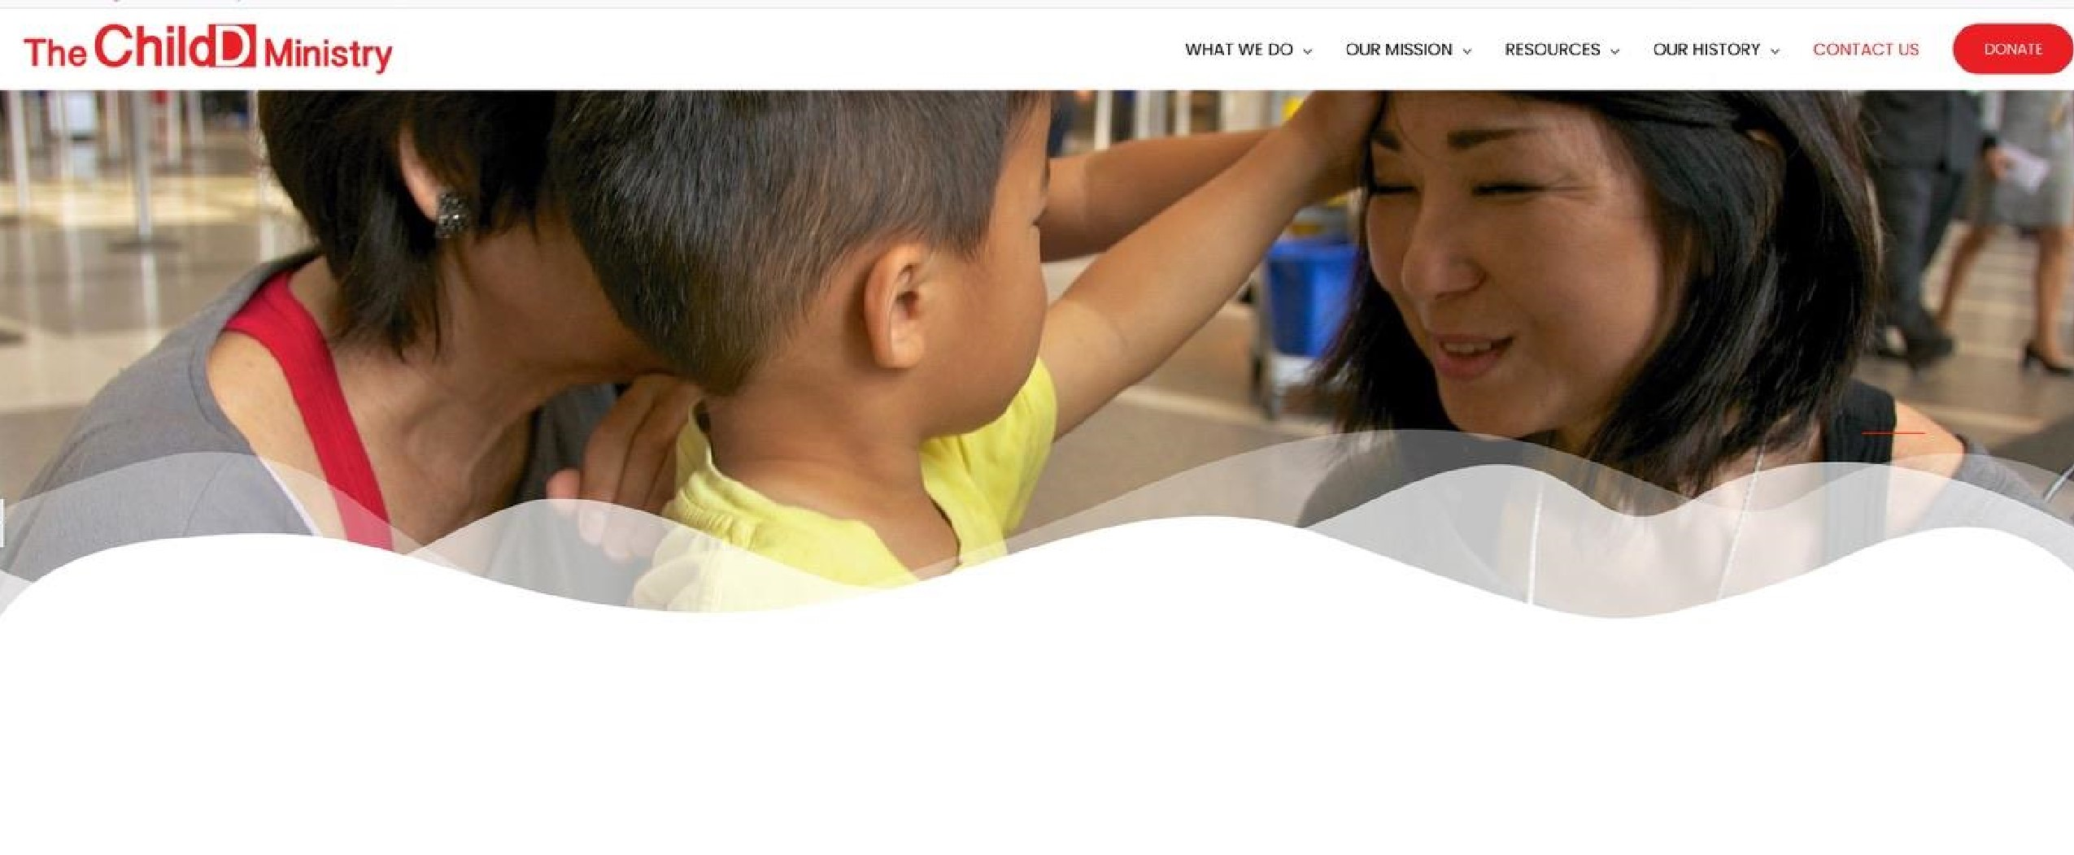
WEBINAR in Japan through Zoom with information coming...

WHERE DOES MY HELP COME?
Practical, life transforming immediate help and guidance
and in a confidential webinar for parents with learning disabilities,
and their children with unique learning challenges and special needs.

Webinar information will be provided by March, 2021.

If you are interested and located in Japan, please send me your email
through any of the "Contact Us" buttons presented on this website.

“Joyce Inouye M.A.Ed. is highly esteemed by other special needs specialists throughout the California Region. Joyce and a colleague pioneered the establishment of the ACSI Special Needs Network which has grown to include over 450 Christian schools. Joyce orchestrates the scheduling of all the special needs seminars, coordinates and hosts the Special Needs Brunch, serving as one of our most capable seminar presenters. She is unique in her approach to services. She serves because of her passion, not due to any remuneration that she might receive. She is to be commended for both her professional contribution and her gift of selfless service.” Jerry Haddock Ed.D. So. California Regional Director Associated Christian Schools International
“Learning disorders have a profound negative impact on children and their families. Through Joyce’s educational ministry, she often is their savior. Joyce’s experience and expertise has been instrumental in identifying specific learning problems in my patients. By identifying the student’s learning dysfunction, individualized plans are developed for the child, the family and the school. Joyce helps children revitalize their joy in learning. Her services promote self-esteem. Most of all, Joyce facilitates children to achieve
educational success. I praise her for her dedication in assisting academically struggling children and their families, and thank her for
all her support over the years.”

Keith S. Miyamoto, M.D., F.A.A.P. Department Chairman of Pediatrics and President of Presbyterian Intercommunity Hospital
"I have known Joyce Inouye M.A.Ed. for over 25 years and find her to be the, most creative, competent and loving Learning
Disabilities Specialist and Educational Diagnostician and Therapist I have ever met. My specialty provides vision therapy for children with visually related learning problems, and in that capacity/ Joyce stands ‘head and shoulders’ above hundreds of diagnosticians and specialists. She has an incredible ability to diagnose the causes of the academic problems and how to get the problems resolved. The bottom line is that children become successful academically, personally, and become achievers in school and life from her intervention."

Don Getz O.D. F.A.A.O., F.C.O.V.D. world renown author & speaker, A. Skeffington, G.N. Getman & President’s Award (College of Optometrists Vis. Dev.)

